Activity4

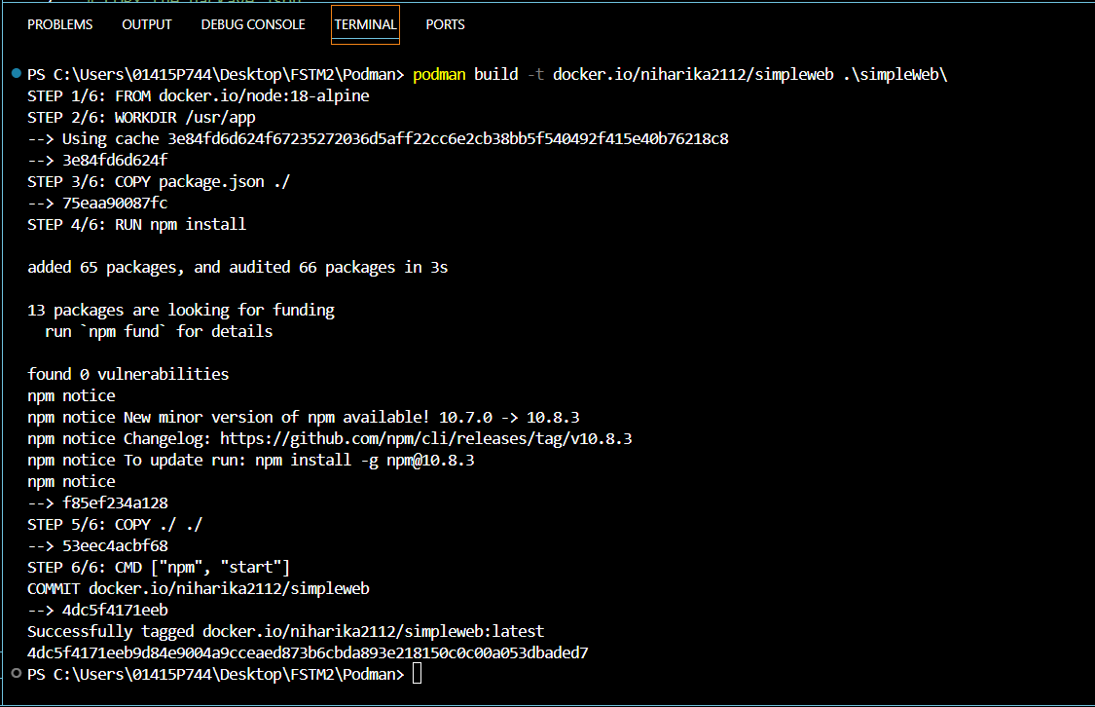

ACTIVITY 5

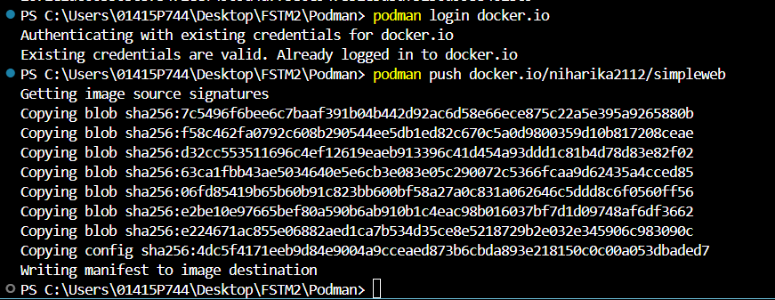

Activity 6

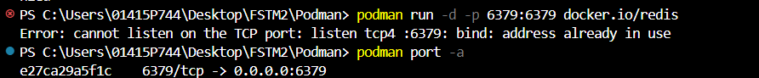

ACTIVITY 7

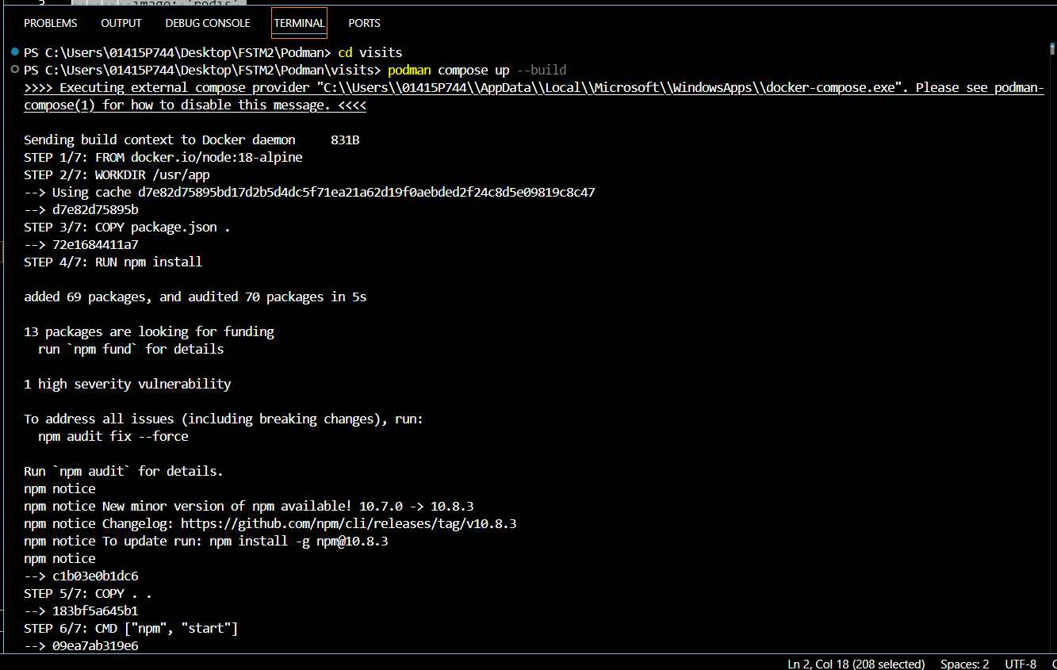

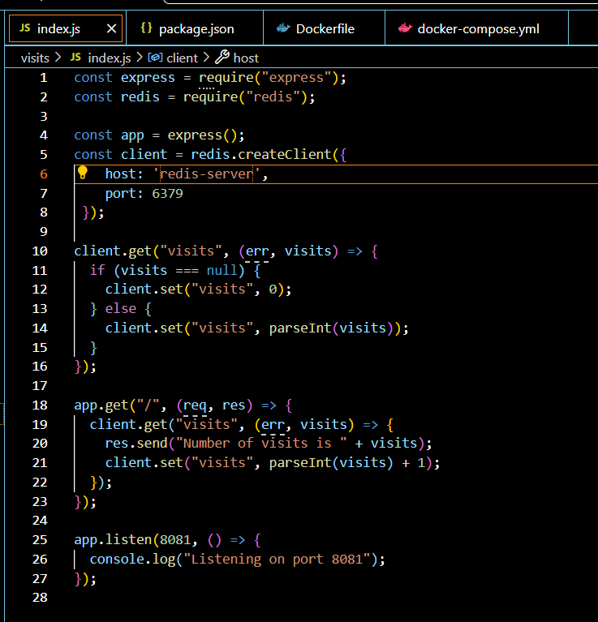

ACTIVITY 8

**Containerizing a Complex Application**

